**NAME:** Tamatam Sivathmika

**REG.NO:**20BCI7197

**ASSINGMENT – 2**

**1) Create update, delete commands in my sql?**

**Code:**

**Update command:**

-- create a table

CREATE TABLE students ( id INTEGER PRIMARY KEY, name VARCHAR(30) NOT NULL,

gender CHAR(1) NOT NULL

);

-- insert some values

INSERT INTO students VALUES (1, 'Ryan', 'M');

INSERT INTO students VALUES (2, 'Joanna', 'F');

-- fetch some values

UPDATE students

SET name = 'Eswar'

WHERE id = 1;

SELECT * FROM students;

**Output:**

**Before updating**

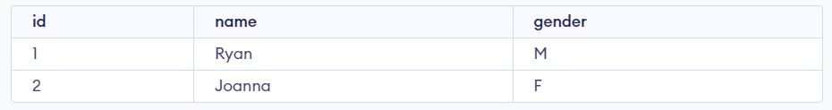

**After updating:**

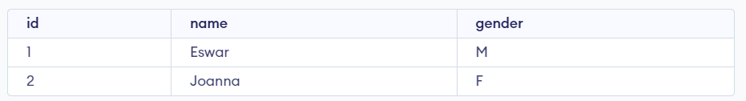

**Delete commands:**

-- create a table

CREATE TABLE students ( id INTEGER PRIMARY KEY, name VARCHAR(30) NOT NULL,

gender CHAR(1) NOT NULL

);

-- insert some values

INSERT INTO students VALUES (1, 'Ryan', 'M');

INSERT INTO students VALUES (2, 'Joanna', 'F');

-- fetch some values

DELETE FROM students

WHERE id = 2;

SELECT * FROM students;

**Output:**

**Before deleting**



**After deleting**



**2) Create a table and perform joins in mySql**

**Inserting data:**

**Code:**

CREATE TABLE student ( id INT PRIMARY KEY, name VARCHAR(50), email VARCHAR(50)

);

CREATE TABLE status ( id INT PRIMARY KEY, status_date DATE, student_id INT,

FOREIGN KEY (student_id) REFERENCES student(id)

);

INSERT INTO student (id, name, email)

VALUES (1, 'Eswar', 'eswar@example.com');

INSERT INTO student (id, name, email)

VALUES (2, 'Rohan', 'rohan@example.com');

INSERT INTO student (id, name, email)

VALUES (3, 'GodLord', 'srikar@example.com');

INSERT INTO student (id, name, email)

VALUES (4, 'siva', 'athma@example.com');

INSERT INTO student (id, name, email)

VALUES (5, 'yashwanth', 'yashwanth@example.com');

INSERT INTO status (id, status_date, student_id)

VALUES (101, '2023-05-01', 1);

INSERT INTO status (id, status_date, student_id)

VALUES (102, '2023-05-02', 1);

INSERT INTO status (id, status_date, student_id)

VALUES (103, '2023-05-03', 2);

INSERT INTO status (id, status_date, student_id)

VALUES (104, '2023-05-04', 3);

INSERT INTO status (id, status_date, student_id)

VALUES (105, '2023-05-05', 4);

INSERT INTO status (id, status_date, student_id)

VALUES (106, '2023-05-10', 4);

INSERT INTO status (id, status_date, student_id)

VALUES (107, '2023-05-05', 5);

select * from student;

select * from status;

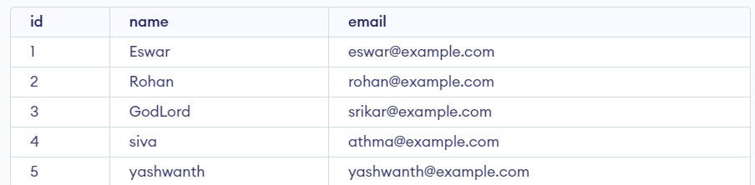

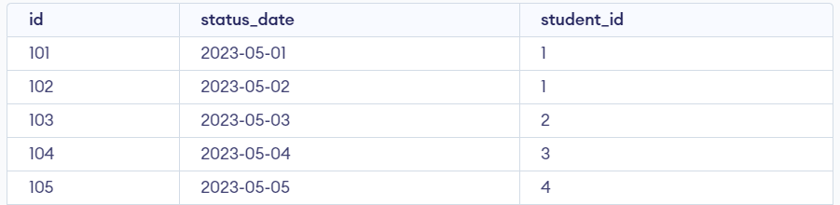



**Performing joins:**

**Code:**

SELECT customers.name, orders.order_date

FROM customers

INNER JOIN orders ON customers.id = orders.customer_id;

**Output:**

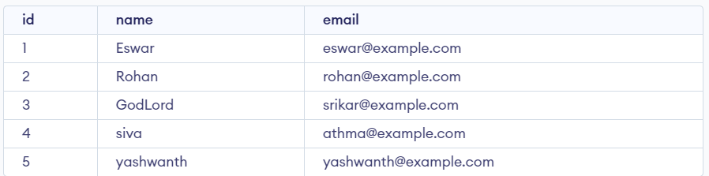

**3) Create update, delete commands in mongodb?**

**Update command:**

**Code:**

db.students.insertMany([

{ id: 1, name: 'Ryan', gender: 'M' },

{ id: 2, name: 'Joanna', gender: 'F' }

]);

db.students.find({ gender: 'F' });

db.students.updateOne(

{ id: 1 },

{ $set: { name: "Ryan Smith", gender: "M" } }

);

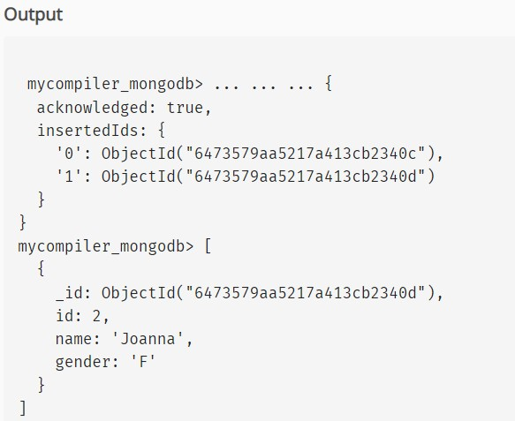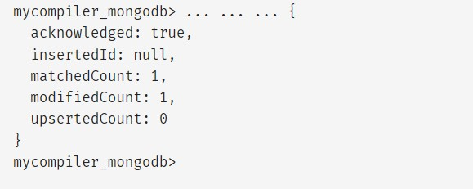

**After updating**

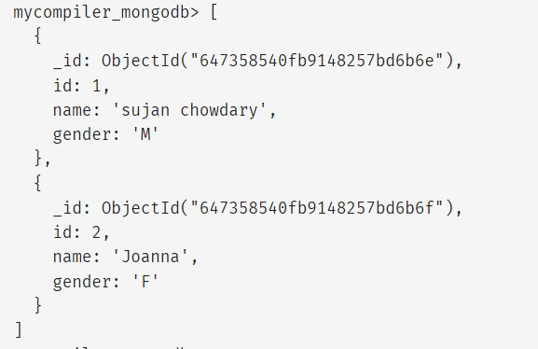

**Deleting commands:**

**Code:**

db.students.deleteOne({ id: 2 }); db.students.find()

**After deleting:**

